# **[Demo 1: Blinky - a Hello World on Arduino ESP32](http://www.iotsharing.com/2017/05/blinky-hello-world-on-arduino-esp32.html)**

1. **Introduction**  
   Let 's start with LED **blinky example, it is equivalent to “Hello World”**. We use **Arduino ESP32 to blink the LED on/off every 1 second**. You can also extend it with a Relay module (as a ON/OFF switch) that can control ON/OFF a high power electric devices such as electric motor, bulb, ... by using a small electric signal from micro controller

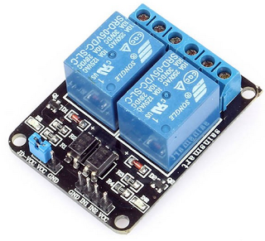

**Figure: Relay module with IN1, IN2 is small input signal from MCU and the opposite side for high power devices**

**2. Hardware**  
For Blinky demo, just connect:  
[ESP3 IO14 and ESP3 GND to LED]

**3.2 Servo**

Create an Arduino project with code:

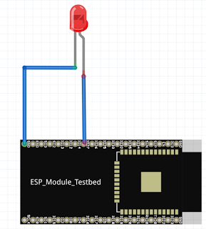

For extension demo, connect:

[ESP32 IO18 - Relay IN1]

[ESP32 GND - Relay GND]

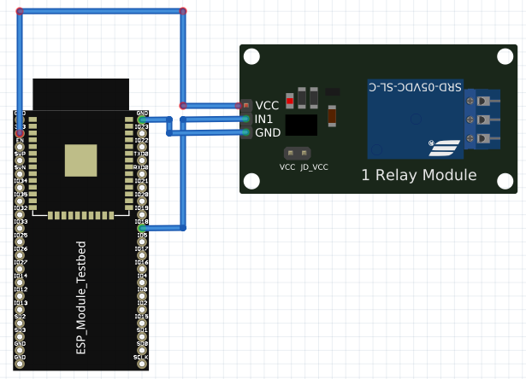

**Figure: ESP32 connect to Relay module**

**3. Software**

If you are familiar with Arduino you see that it is very easy. First we use **pinMode()** function to set the pin IO14 as **OUTPUT.** Then we set the HIGH level for pin IO14 by using **digitalWrite()**function. We need a little **delay** so that we can monitor the LED is ON or OFF.

Start Arduino IDE > **File > New > Save As > esp32led**  
Select your board in > **Tools > Board > ESP32 Dev Module**  
Select Upload Speed in **> Tools > Upload Speed > 115200**  
Select Flash Frequency in **> Tools > Flash Frequency > 80MHz**  
Select the COM port that the board is attached to in **> Tools > Port**  
Then Compile and Flash SW to ESP32

|  |
| --- |
| int led = 14;  void setup() {  pinMode(led,OUTPUT)  }  void loop() {  digitalWrite(led,HIGH)  delay(1000);  digitalWrite(led,LOW);  delay(1000);  } |

**Figure: Press red button to compile and flash SW to ESSP32**